1) **HTTP**

HTTP, Hypertext Transfer Protocol, In 1989, Tim Berners-Lee invented HTTP.

The communication protocol – your aid in reaching World Wide Web.

HTTP 1.1 vs HTTP/2:

HTTP/1.1, the first standardized version of HTTP, was introduced in 1997. It presented significant.

performance optimizations (over HTTP/0.9 and HTTP/1.0) and transformed the way requests and responses.

were exchanged between clients and servers.

At the beginning of 2010, Google introduced an experimental protocol, SPDY, which supported multiplexing.

(Multiple requests/responses sent and received asynchronously over a single TCP connection) but as it gained.

traction IETF’s HTTP Working Group came up with HTTP/2 in 2015, which is based on the SPDY protocol.

**How Connections Work Between Server and Client**



**Difference Between 1.1 vs 2 in protocol**

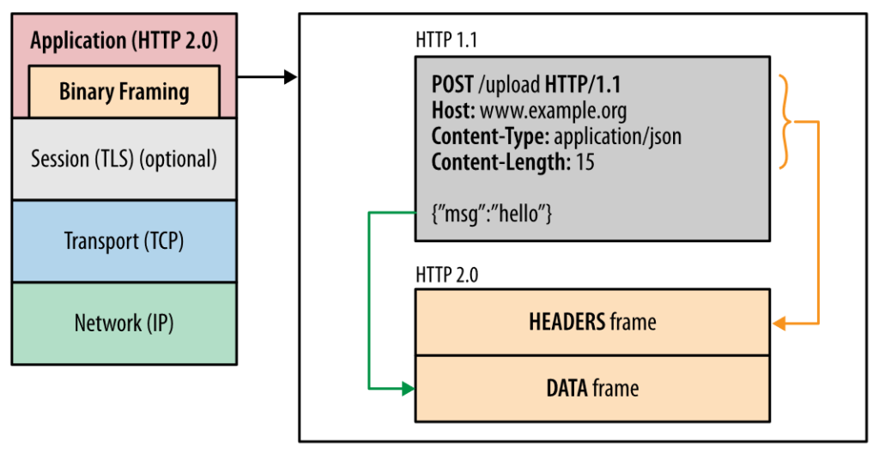

**Both Performance and Response Time Between 1.1 vs 2**

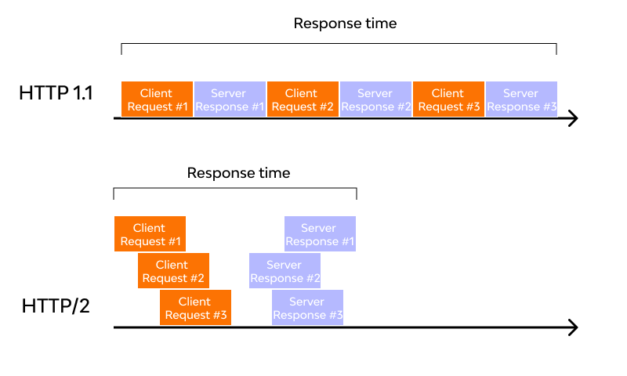

2) **Objects and its internal representation in JavaScript**

Objects in JavaScript may be defined as an unordered collection of related data, of primitive or reference.

types, in the form of “key: value” pairs. These keys can be variables or functions and are called properties.

and methods, respectively, in the context of an object.

**Syntax:**

var <object-name> = {key1: value1, key2: value2,... keyN: valueN};

**Example:**

var car = {Make: “Mercedes”, Model: “C-Class”, Colour: “White”, Fuel: Diesel,

Weight: “850kg”, Mileage: “8Kmpl”, Rating: 4.5};

